31.201 |  | Fitness equipment Counterweight pull-ups and push-ups
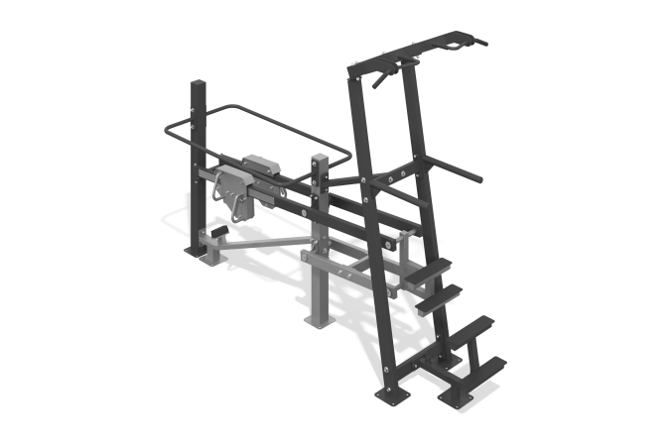

Size, mm: | 1830x3940x3000 | Weight, kg: | 310
Material characteristics
Materials: metal, plastic.
The simulator is designed to train the back muscles and develop the upper shoulder girdle. The design of the simulator is dismountable, the elements are welded. The simulator is attached to a support column made of a steel profile pipe 100 mm x 100 mm with a wall thickness of 4 mm, and a steel sheet 10 mm thick. The main frame of the simulator is made of a steel profile pipe measuring 100 mm x 50 mm with a wall thickness of 3 mm, bent using the mandrel method, which eliminates deformation of the pipe surface in the form of waves and creases at bending points, a steel profile pipe measuring 80 mm x 40 mm with a wall thickness of 3 mm, and a steel sheet with a thickness of 10 mm.
The main frame includes a multi-grip horizontal bar, push-up bars and a step system.
The multi-grip horizontal bar, made of bent steel rod with a diameter of 25 mm, has three grip positions when performing pull-ups. In the grip areas on the handles of the horizontal bar there are pads made of polyurethane.
The push-up bars are made of steel pipe with a diameter of 48 mm and a wall thickness of 2.8 mm. The distance between the handles of the bars is 500 mm. The system of steps for the convenience of taking the starting position is made of a steel profile pipe measuring 50 mm x 50 mm with a wall thickness of 3 mm, bent using the mandrel method, which eliminates deformation of the pipe surface in the form of waves and creases in places of bending and corrugated steel sheet 4 mm thick. The size of the step platforms is 430x110mm.
The exercise machine includes a counterweight system with weights. The principle of operation of the counterweight: a movable lever for moving a weight transfers the load to a supporting movable platform. The direction of movement is provided by auxiliary levers made of steel profile pipe 80 x 40 mm with a wall thickness of 3 mm.
The movable arm of the simulator is made of a steel profile pipe measuring 80 mm x 40 mm with a wall thickness of 3 mm, which has 10 grooves on one side in the load movement zone for fixing the position of the load, a steel pipe with a diameter of 60 mm and a wall thickness of 6 mm, and a steel sheet with a thickness of 10 mm.
The supporting movable platform for users of different heights is made of steel profile pipe measuring 50 mm x 50 mm with a wall thickness of 3 mm, and corrugated steel sheet 4 mm thick.
The simulator is equipped with a mechanism for regulating the counterweight system - at least two weights. The weight is a movable load, made in the form of a set of welded steel sheets 10 mm thick with a system to ensure smooth movement. The movable weight can be moved and fixed in ten positions on the movable arm to increase resistance (load). The mass of the moving load is 50 kg. The movable weight has a conveniently shaped grip and a key for adjusting the position of the weight lock. Keeping the key pressed allows the load to move along the movable arm. Fixing the load in a certain position of the lever is achieved by releasing the key. Additional safety fixation of the weight with a stainless screw is provided.
The movement area of ​​the working lever of the simulator is equipped with safety limiters made of a bent round pipe with a diameter of 33 mm with a wall thickness of 2.8 mm, corresponding to a steel sheet with a thickness of 10 mm.
To increase anti-corrosion properties, metal elements are coated with liquid zinc-rich primer.
All metal elements are coated with anti-vandal decorative powder coating by pneumoelectrostatic spraying.
The simulator fasteners are galvanized.

