31.067 |  | Fitness Station 500
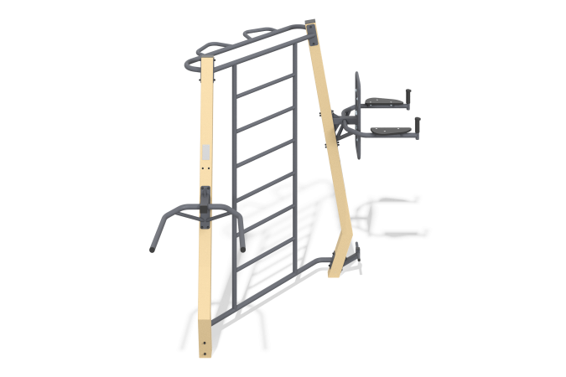

Size, mm: | 1430x3175x2330 | Weight, kg: | 124.2158
Material characteristics
Materials: Structural steel, laminated plywood, plastic elements.
Coating of elements: Polymer coating of metal.
Fasteners: Galvanized hardware.
Complex equipment:
Metal stands – 2 pcs.
Swedish wall canopy - 1 pc.
Canopy beams – 1 set
Canopy press with emphasis on hands – 1 set
Canopy horizontal bar with handles – 1 set
Footrest - 1 pc.
Set of hardware – 1 pc.

