MG3601.1 |  | Pole with rope on the slope
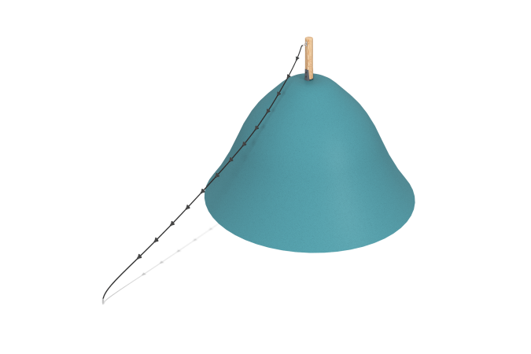

Size, mm: | 140x3620x2250 | Weight, kg: | 12.8
Material characteristics
Straight slides h = 1 m. they consist of a ramp and sides. The ramp, in turn, is made of a 1.5 mm thick stainless steel sheet, and the sides are made of a round stainless pipe with a diameter of 26.9 mm with a wall thickness of 2 mm. The launch pads of the straight slides are equipped with a metal crossbar made of a round pine bar with a diameter of 90 mm.

