FS21801 |  | Fitness Equipment
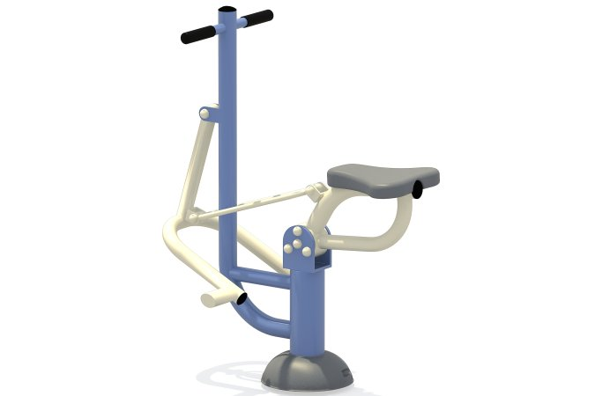

Size, mm: | 599x1002x1210 | Weight, kg: | 0
Material characteristics
The main post is Φ 114mm, 89mm, the auxiliary pipe is Φ 48mm, 38mm, 32mm. The national standard welded high-quality galvanized steel pipe with thickness of 2.5mm is adopted. follows the specifications of major international manufacturers and achieves high resistance. The tensile strength can reach .
Surface treatment for post：after the whole processing and forming, it is treated by degreasing thermochemical treatment, and the welding part is treated by rust prevention. The raw material of spraying plastic powder is applied by the outdoor environmental protection polyester powder spray from Aksu in Netherlands. The surface is treated by low metal electrostatic powder spraying, which conforms to the national safety standard for metal content. The powder spraying material is added with anti UV stabilizer to reach the 5 level anti UV standard, the color can remains bright for a long time.
Imported polyethylene engineering plastic material，the material is granulated and modified to enhance the strength performance of the product，formed by one-time rotational molding, with impact resistance, UV resistance of more than six levels, anti-static, low temperature resistance, wear resistance and non embrittlement.
Fastener：304stainless steel；type：half round head inner hexagon safety screw and T-flat head hexagon screw, general tools can’t loosen it so can prevent any adjustment .

