37.007 |  | Scientific module Electric labyrinth
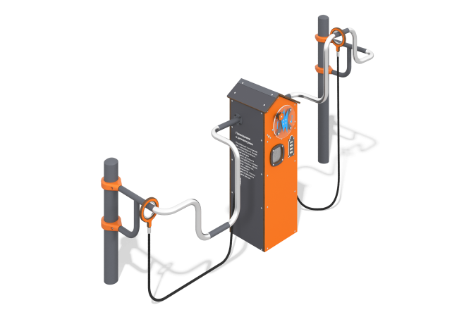

Size, mm: | 750x2680x1550 | Weight, kg: | 123.57
Material characteristics
Educational game module
The product is a structure consisting of two support posts and a housing, to which an electric labyrinth made of stainless pipe and two connectors on a reinforced rope are attached. The generating set is located inside a housing with a gable roof made of HPL plastic. The case is equipped with a charge indicator in the form of a battery, a speaker, short circuit/loss indicators, and a rotating panel made of monolithic polycarbonate with a handle, the rotation of which charges the generator.
Materials: metal with a layer of zinc-containing primer, polypropylene six-strand reinforced rope, stainless steel, HPL plastic.

