22.081 |  | Straight tunnel slide H4000
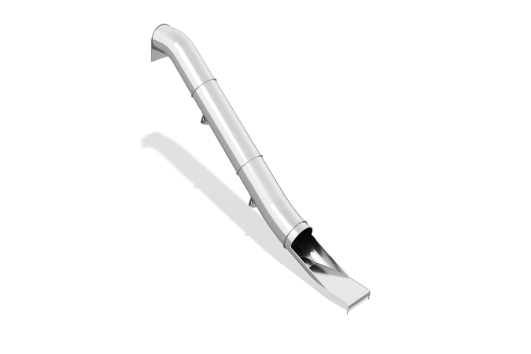

Size, mm: | 870x7525x5015 | Weight, kg: | 358.14452
Material characteristics
Main materials: stainless steel.
The long part of the slide, as well as the rotating parts, are made of stainless steel sheet 2 mm thick. The entrance flange to the slide is made of stainless steel 4 mm thick. The slide edging pipe is presented in the form of a round stainless pipe with a diameter of 26.9 mm and a wall thickness of 2 mm.

