38.003 |  | Canopy for baby strollers 8 m
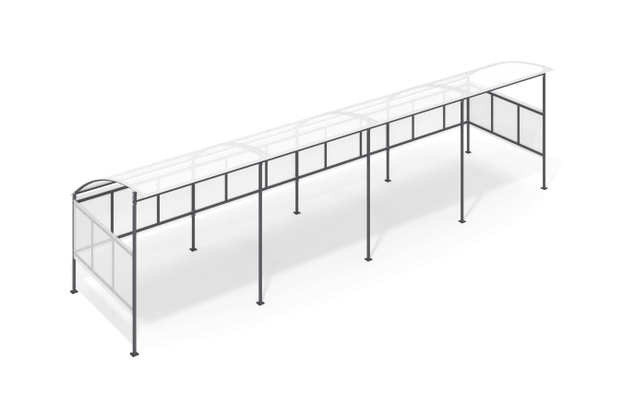

Size, mm: | 2394x8440x2270 | Weight, kg: | 261.106
Material characteristics
Materials: Metal, cellular polycarbonate, powder paint.
Metal parts are coated with a protective anti-corrosion decorative coating selected to ensure weather resistance and light resistance.
Bolted frame made of profile pipe 40x40 mm with a wall thickness of 2 mm, 40x20 mm with a wall thickness of 2 mm, 40x20 with a wall thickness of 1.5 mm. All frame metal elements are painted with a protective anti-corrosion decorative coating.
The side and rear walls, as well as the roof, are made of 10 mm thick cellular polycarbonate.
Contents: Frame - 1 piece, Roof - 1 piece, Side walls - 2 pieces, Rear wall - 1 piece.

