23.007 |  | Educational Module Mechanic
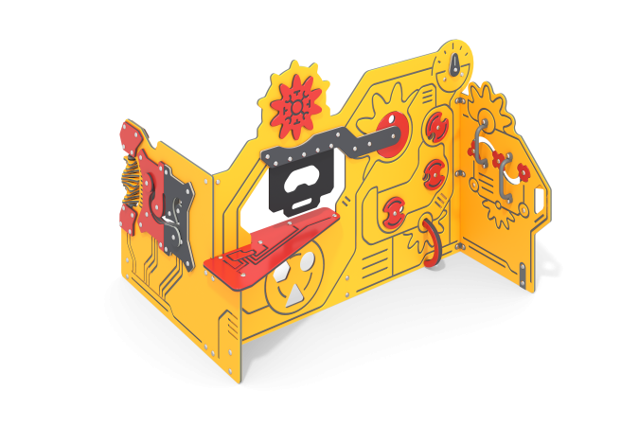

Size, mm: | 1450x1650x1200 | Weight, kg: | 83
Material characteristics
Materials: metal, powder paint, HDPE plastic.
The main decorative panels and developmental elements are made of sheets of low-density polyethylene HDPE (high density - HDPE) of different colors, 15 mm thick, which is used in the production of children's complexes.
Vertical panels are equipped with various mechanisms and elements in the form of rotating gears of different shapes and sizes, round disks, various puzzles and labyrinths with movable sliders, designed to develop logical thinking and motor skills.
Individual developing elements are made of monolithic polycarbonate with a thickness of 6 mm and 3 mm.
The panels are decorated with decorative milling in the form of lines and various shapes.
The window blind is made of reinforced rubber with a thickness of 10 mm.
The product uses elements made of a round stainless steel pipe with a diameter of 26.9 mm and a wall thickness of 2.0 mm.
The embedded supporting elements are made of plates 6 mm thick and 400 mm long.
Equipment: Mechanic stand – 1 set; fastening kit – 1 pc.

