35.029 |  | Barrier for dogs
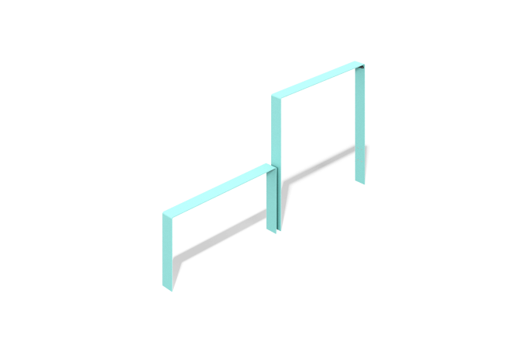

Size, mm: | 100x2053x1007 | Weight, kg: | 0
Material characteristics
Product dimensions:
Width - 100 mm; length - 2053 mm; height - 1007 mm
Materials: metal.
Equipment: crossbar - 2 pcs.
The "Barrier" element is a crossbar for dogs made of metal sections. The crossbars of the product are made of a bent metal sheet with a thickness of 6 mm.
Coating of the elements:
- metal - powder zinc primer, powder paint

