MG1504 |  | House
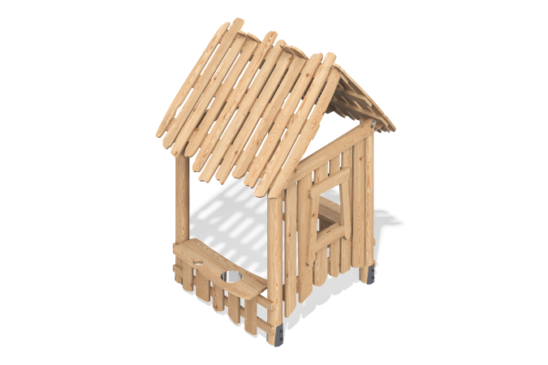

Size, mm: | 1440x1814x2455 | Weight, kg: | 0
Material characteristics
The playhouse design provides a safe and comfortable space for children to play, fostering the development of their imagination and social skills.
Materials and Construction:
Support posts: Made of rounded larch timber with a diameter of 140 mm. This material ensures high strength and stability.
Playhouse Frame: Made of larch boards, which are highly wear-resistant and resistant to environmental influences.
Finish: The larch support posts are coated with AP 292 primer to protect against moisture and other external influences. The larch is coated with a transparent matte varnish, which highlights the natural texture of the wood and provides additional protection.
Features:
The playhouse is designed with safety in mind: no sharp corners and non-toxic materials.
The spacious interior allows children to play and relax comfortably.

