MG3405 |  | Educational Module Theater
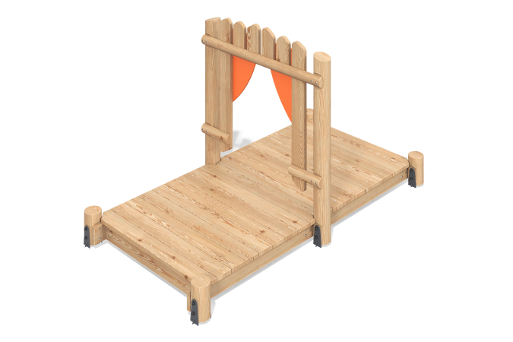

Size, mm: | 1560x2860x1630 | Weight, kg: | 183.1526
Material characteristics
Materials: larch timber, metal, planed larch boards, moisture-resistant birch plywood, stainless steel fasteners.
Package includes: 1 set of embedded parts, 6 support posts, 1 set of floors, 1 set of "Theater" decorative elements, 1 set of fasteners.
The element's support posts are made of rounded larch timber with a diameter of 140 mm. The house floors and their frame are made of larch boards measuring 35 mm x 140 mm.
The set includes:
- a "Theater Curtains" decorative element made of moisture-resistant birch plywood 15 mm thick.
- a "Curtain" decorative element made of larch timber with a diameter of 90 mm. - a decorative element for the theater's cladding, made of 140x35 mm larch boards.
The set uses stainless steel fasteners. Protruding threaded connections and exposed pipe sections are covered with plastic plugs.
Element finish:
- Metal: zinc powder primer, powder paint;
- Timber: water-based varnish;
- Plywood: acrylic primer, acrylic enamel, water-based varnish.

