MG3002 |  | Slide on the slope
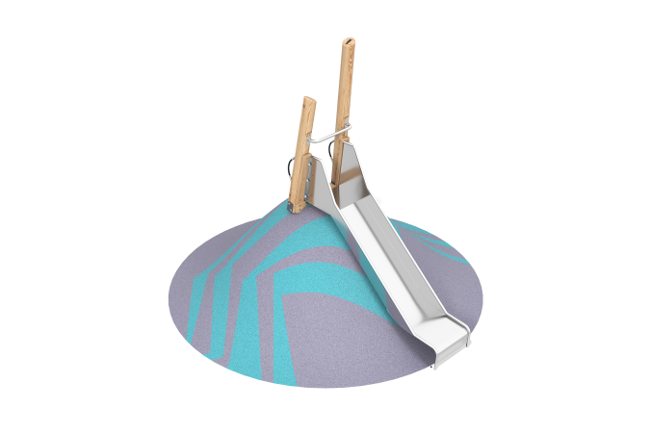

Size, mm: | 782x1964x2597 | Weight, kg: | 70.8071
Material characteristics
The game complex includes 1 straight slide.

