34.278 |  | Park sofa
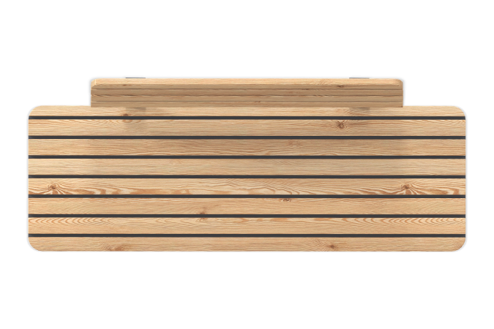

Size, mm: | 641x2000x790 | Weight, kg: | 0
Material characteristics
Materials: metal, wood, powder primer, powder paint, oil impregnation.
The bench with a backrest is a prefabricated welded metal frame with boards mounted on it.
The metal frame consists of 3mm, 8mm thick sheet metal.
The seat and back are presented in the form of a 70 mm wide larch board with a thickness of 30 mm.
The metal frame is covered in 2 layers. 1 layer is powder primer, 2 layers are powder paint. All fasteners are galvanized.
The boards are fixed with yellow zinc M4x30 structural screws.
Package contents:
Bench with backrest assembly – 1 pc.

