19.026 |  | Sandpit Mountains and forests
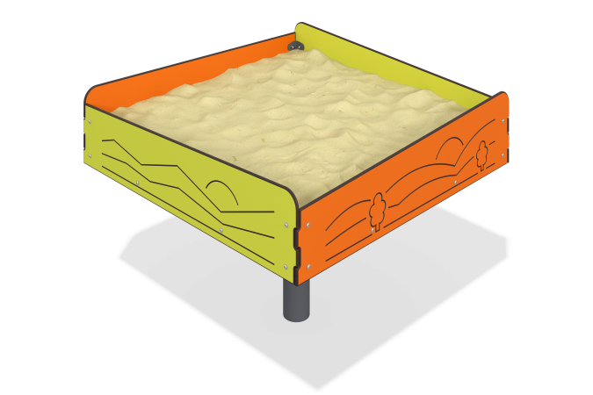

Size, mm: | 1000x1000x750 | Weight, kg: | 41.089
Material characteristics
Sandbox "Mountains and forests" (HPL plastic (plastic, polyethylene)). It is a rectangular box with walls of different heights, made of three-layer HPL plastic (plastic, polyethylene) 12mm thick. On the outer part of the box there are thematic drawings made with a milling cutter. Inside the box there is a bottom made of laminated plywood 15mm thick; under the bottom there is a base made of a metal profile 40mm wide x 20mm long x 2mm thick, which in turn is fixed to a frame made of a square metal pipe 80mm wide x 80mm long x 3mm thick, which is a mortgage. The fasteners are made with furniture bolts M8x50 mm, furniture screws M6x10 mm and nuts M8, M6. All bolted connections are closed with plastic plugs. The metal is painted with basalt-gray polymer paint. Installation is carried out by deepening the embedded parts to a depth of 0.5 m, followed by concreting.

