23.043 |  | Play Panel Naughts and Crosses
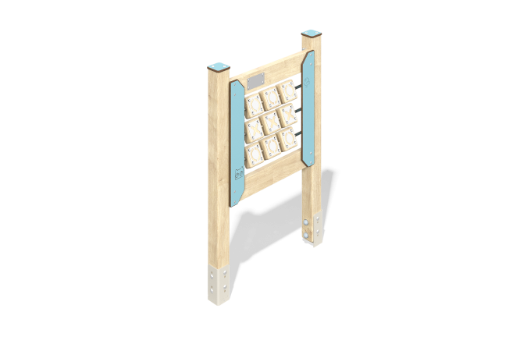

Size, mm: | 90x769x1132 | Weight, kg: | 20.6
Material characteristics
Material: softwood timber, HPL plastic, metal, stainless steel, stainless fasteners.
Contents: embedded parts – 1 set, support posts – 2 pcs., Tic-Tac-Toe panel – 1 pc., fastening set – 1 pc.
Design and color palette of equipment according to the sketch.
The educational element consists of two supports made of laminated veneer lumber, on which the Tic-Tac-Toe game panel is fixed. The support posts are made of laminated coniferous timber with a cross-section of 80x80 mm. The profile is square, the corner radius is R10.
The cubes on the panel are made of laminated coniferous timber with a cross-section of 100x100 mm. The cubes are mounted on a round stainless steel pipe. The “cross” and “toe” plates, which are attached to the timber cubes, are made of stainless steel sheet 1.5 mm thick.
Decorative elements such as overlays are made of HPL plastic 10 mm thick. Drawings are applied to decorative overlays using engraving.
Caps made of HPL plastic with UV protection 10 mm thick are installed on the upper part of the support posts.
The gaming panel uses stainless steel fasteners. Protruding parts of threaded connections and open parts of pipes are closed with plastic plugs.
The Tic Tac Toe game board is designed for thematic play and motor skills development. Purpose of the game “Tic Tac Toe”: Players take turns placing the cube straight (one is always tic tac toe, the other is always toe). The first one to line up 3 of his pieces vertically, horizontally or large diagonally wins.
Element coverage:
- metal - powder zinc primer, powder paint;
- timber - glazing primer, water-dispersion varnish.

