38.004 |  | Canopy for baby strollers 6 m
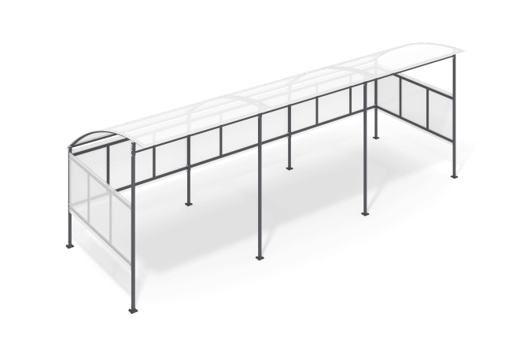

Size, mm: | 2394x6340x2270 | Weight, kg: | 204.873
Material characteristics
Materials: Metal, cellular polycarbonate, plastic.
The canopy for baby strollers is an assembly frame made of a profile pipe 40x40 mm with a wall thickness of 2 mm, 40x20 mm with a wall thickness of 2 mm and 20x20 mm with a wall thickness of 1.5 mm. Metal parts are painted with polyester powder paint. The roof and walls are 10 mm thick cellular polycarbonate mounted on a frame.
Equipment: Side stands – 2 pcs; racks - 4 pcs., fences - 3 pcs.; roof frames - 3 pcs; side panels - 2 pcs; rear panels - 3 pcs; roof panels - 3 pcs; profiles - 22 pcs; fastening kit - 1 pc.

