23.096 |  | Educational Module Workshop
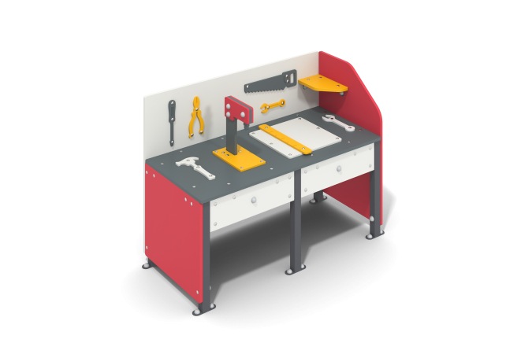

Size, mm: | 540x1130x830 | Weight, kg: | 36.203
Material characteristics
Main materials: Plywood, profiled steel pipes, stainless fasteners.
Contents: embedded parts - 1 set, support posts - 4 pcs., tabletop with decorative elements - 1 pc., side panels with decorative elements - 4 pcs., shelf - 1 pc., fastening set - 1 pc.
The product is presented in the form of a game element, consisting of load-bearing racks and panels with decorative elements.
The racks are made of profile pipe 40x40 mm with a wall thickness of 2 mm, the mortgages are made of profile pipe 40x20 mm with a wall thickness of 2 mm, the walls are made of plywood 15 mm thick, the decorative elements are made of plywood 9 mm thick. The side walls are connected to the posts and mortgages using corners made of 3 mm thick steel and stainless steel fasteners.
Element coverage:
- metal - powder zinc primer, powder paint;
- plywood - water-based paint.

