25.010 |  | Trampoline Round d = 2100
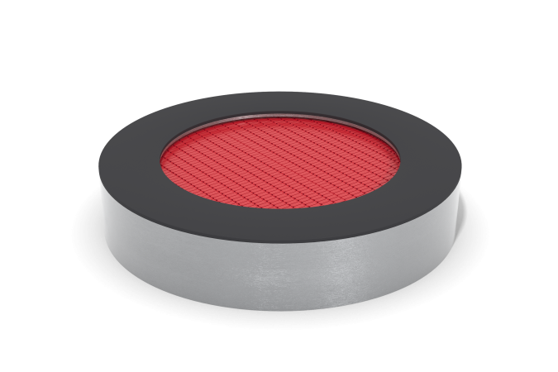

Size, mm: | 2100x2100x420 | Weight, kg: | 300
Material characteristics
Materials: frame – galvanized steel 3 mm thick; jumping surface - elements made of TPR, steel rope 4 mm thick; sides - EPDM chips.
Round trampoline with a diameter of 1900 mm. Jumping surface size d=1510mm. The frame of the trampoline is made of galvanized steel sheets 3 mm thick and has additional stiffening ribs inside. Handles are installed on the metal frame on the outside to ensure the transfer and installation of the trampoline.
The jumping surface is assembled from assembled elements made of compacted technical thermoplastic elastomer with high resistance to abrasion and weathering. The elements of the canvas are connected to each other by steel ropes (cables) 4 mm thick and form a continuous jumping surface without gaps between the individual elements.
The ends of the cables are connected through thimbles to the body using cone-shaped springs hidden under the frame of the trampoline. The springs have a galvanic coating and an elongated ear shape for easy access when servicing the trampoline.
To ensure safety, the edges of the trampoline are covered along the perimeter with rubber plates 300 mm wide and 20 mm thick, made of EPDM chips.

