34.281 |  | Armchair with backrest
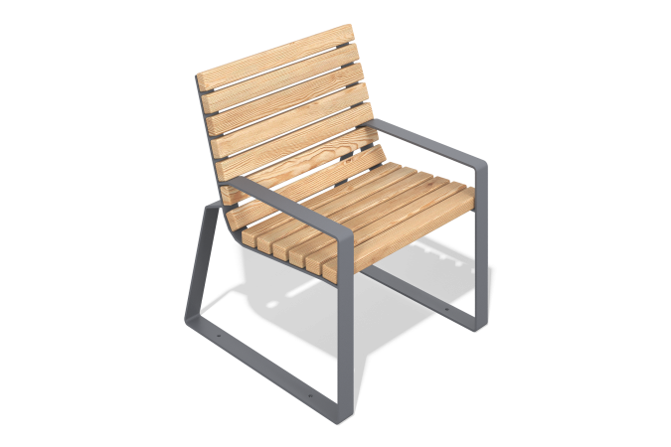

Size, mm: | 750x700x810 | Weight, kg: | 35
Material characteristics
Materials: metal, larch, lacquer.
Package contents: sofa - 1 pc.
The sofa is a welded metal frame made of profile pipes with wooden boards fixed on it. The frame is painted with weather-resistant powder paint, and the wooden elements are coated with a protective varnish resistant to moisture and UV. All fasteners are galvanized."

