MG0517 |  | Double swing
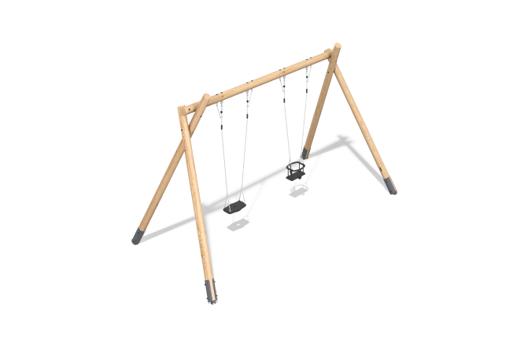

Size, mm: | 2418x5022x2972 | Weight, kg: | 198.2103
Material characteristics
Horizontal bridges made of six-row reinforced polypropylene rope d =16 with pine planks, horizontal bridges made of six-row reinforced polypropylene rope d=16 with rope and reinforced rope 140 x 140 mm with a steel core of 10 mm, suspended platforms made of plywood 18 mm and boards 25 x 140 mm, horizontal beams with a diameter of 140 mm, horizontal ropes of six-row reinforced polypropylene rope d=16,

