17.039 |  | Oval Rope Seat Nest
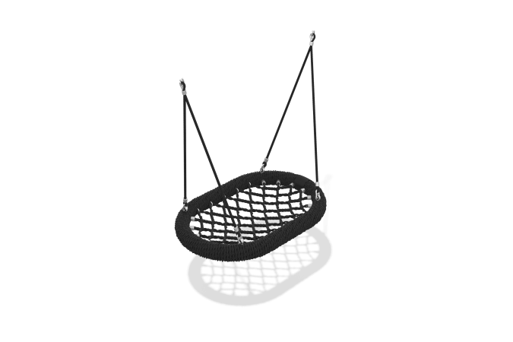

Size, mm: | 800x1200x1240 | Weight, kg: | 24.86
Material characteristics
Materials: metal, rope.
Complete set: nest suspension - 1 pc., fastener kit - 1 pc.
The nest ring consists of a frame made of a pipe with a diameter of 33.5 mm and a wall thickness of 2.8 mm, made of steel 20, wrapped with a 3-strand 19 mm rope made of complex polypropylene. Steel compression sleeves made of steel 20 are used to attach the net to the swing frame. The nest net is made of a reinforced 4-strand rope with a diameter of 16 mm. Rolled tubular steel with an outer diameter of 33.5 mm and a wall thickness of 3.2 mm is used to make the nest frame. The rope suspension is made of a six-strand reinforced polypropylene rope. Aluminum compression sleeves are used to connect rope slings and round-link chains. A special rigging bracket made of stainless steel with a safety plate is used to hang the product. The protruding parts of the threaded connections and the open parts of the pipes are covered with plastic plugs
Coating of the elements: metal - powder zinc primer, powder paint.

