35.035 |  | Canopy
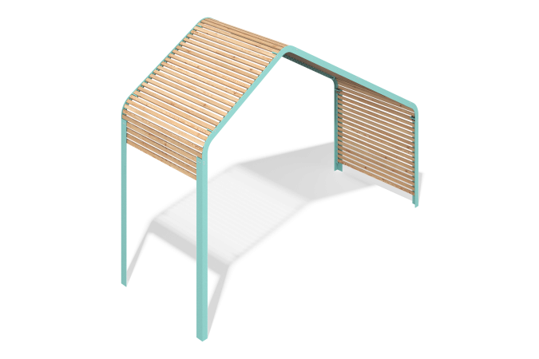

Size, mm: | 1770x4740x3453 | Weight, kg: | 322
Material characteristics
Materials: larch, metal.
Equipment: frame sections - 14 pcs., fastening kit 1 pc., canopy beam kit 1 pc.
The gazebo frame sections are made of 8 mm and 3 mm thick metal sheets, as well as 60x60 mm profile metal pipes with a 3 mm thick wall. The ties are made of a 3 mm thick metal sheet and a 60x30 mm profile metal pipe with a 2 mm thick wall. The canopy is made of 50x30 mm planed timber.
The equipment uses stainless steel fasteners.
Coating of the elements:
- metal - hot-dip galvanizing, powder paint (RAL 6027 moire);
- timber - water-based varnish.

