34.255 |  | Slide h=950 (HPL)
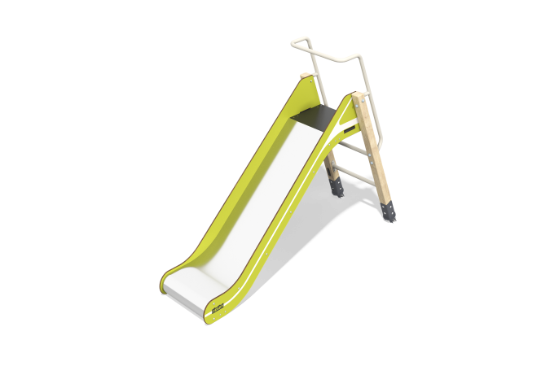

Size, mm: | 680x2149x1588 | Weight, kg: | 63.296789
Material characteristics
Materials: stainless steel, HPL plastic, coniferous wood- pine, metal.
The 950 mm high children's slide is designed for installation in play complexes and playgrounds.
The sides of the slide are made of high-strength HPL (High Pressure Laminate) laminate with a thickness of 10 mm. The ramp is made of 1.5 mm thick stainless steel sheet. The support posts are made of square pine timber with a cross section of 80 × 80 mm.
Wood treatment: two-layer application of AP 292 primer (acrylic-based antiseptic, protection against bio-contamination, UV radiation and moisture) and matt varnish.
The steps and handles are made of round metal tube. The metal is coated with zinc primer.
The floors on the slide platform are made of laminated plywood 18 mm thick.

