34.041 |  | Double Park Gazebo
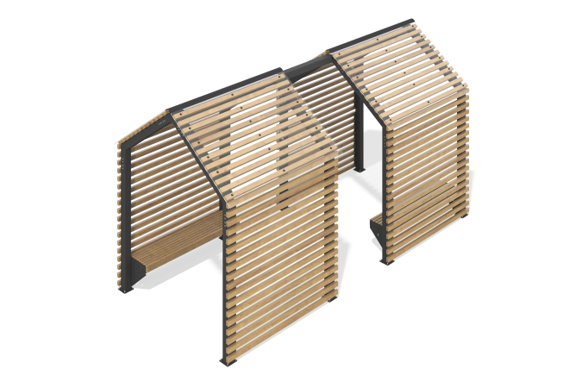

Size, mm: | 2380x4990x2754 | Weight, kg: | 689.482
Material characteristics
Materials: Metal, coniferous wood, monolithic polycarbonate, powder paint.
Gazebos are a single structure connected by a beam. The frame of the gazebo is made of metal profile pipe 100 mm x100 mm and 3 mm thick.
The walls, roof of the gazebo and seats of the benches are made of planed wooden beams with a section of 35x45 mm. The floor is made of boards with a section of 32x110 mm. The side walls of the benches are made of sheet metal 2 mm thick. Monolithic polycarbonate sheets 5 mm thick are installed on the roof.
All elements made of wood are sanded and the edges are rounded. The treated surfaces are covered with tinted and colorless varnish.
All existing metal parts are painted with polyester powder paint.
All threaded fasteners are galvanized.
Contents: gazebo – 2 sets, central bank – 1 piece.

