40.063 |  | Panna football
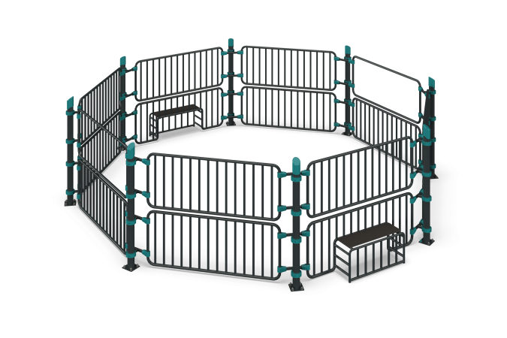

Size, mm: | 6860x6860x1894 | Weight, kg: | 581.3
Material characteristics
Panna Football Court. It consists of eight support posts with embedded fittings made of 108 mm diameter round metal tubing with a 3.5 mm wall thickness.
Welded sections of three types are available: a closed section, a goal section, a passage section, and an auxiliary section fastening element. All sections are made of 42.3 mm diameter round metal tubing with a 3.2 mm wall thickness, and 33.5 mm diameter round metal tubing with a 2.8 mm wall thickness.
All metal parts are shot-blasted, cleaned, and degreased, then painted with polyester powder paint.
Seats are installed on the reverse side of the goal sections. They are made of high-strength, moisture-resistant, 15 mm thick laminated plywood, covered with a 120-220 g/m² phenolic or melamine film, featuring the signature "hexagonal structure" pattern. The plywood ends are painted with acrylic paint.
The support posts are secured to the embedded parts with M20x40 hex bolts, washers, and spherical cap nuts.
The sections are secured to the support posts with 108 mm diameter metal clamps, plastic pipe connectors, and fasteners.
The seats are secured to the gate section with M6x45 screws, washers, and nuts.
The pipe ends are capped.
Included:
Support post - 8 pcs.
Embedded part - 8 pcs.
Closed section - 12 pcs.
Gate section - 2 pcs.
Walkway section - 2 pcs.
Seat - 2 pcs.
108 mm pipe caps - 8 pcs.
S32-32KS pipe connector - 64 pcs.
Metal clamp - 32 pcs.
Fastener kit - 1 pc.

