17.052 |  | Swing Frame Paws
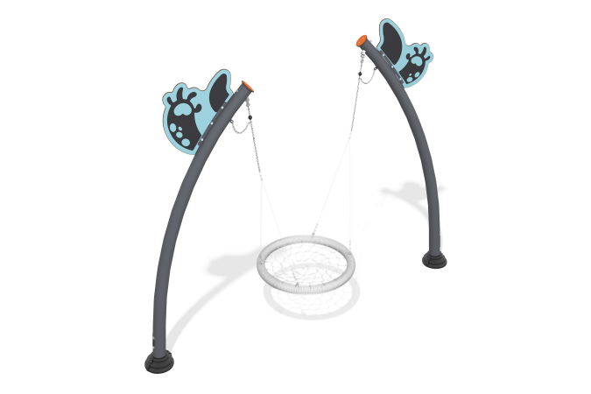

Size, mm: | 1147x3760x2954 | Weight, kg: | 188.373
Material characteristics
Materials: Metal, HPL plastic.
Contents: Swing stands – 2 pcs., decorative panels – 2 pcs., fastening kit – 1 pc.
Design and color palette of equipment according to the sketch.
The swing frame consists of 2 posts. The swing consists of two bent pipes on which the “nest” suspension is suspended. The inclined support posts are made of pipe with a diameter of 133 mm and a wall thickness of 3 mm. The suspension is connected to the support posts through a joint with hinges made of stainless steel 2 mm thick.
The complex uses stainless steel fasteners.
Decorative panels "Paws" are made of double-sided HPL plastic with UV protection, 14 mm thick. Drawings are applied to the panels using engraving and UV printing.
Element coverage:
- metal - powder zinc primer, powder paint.

