30.081 |  | Basketball unit Tap
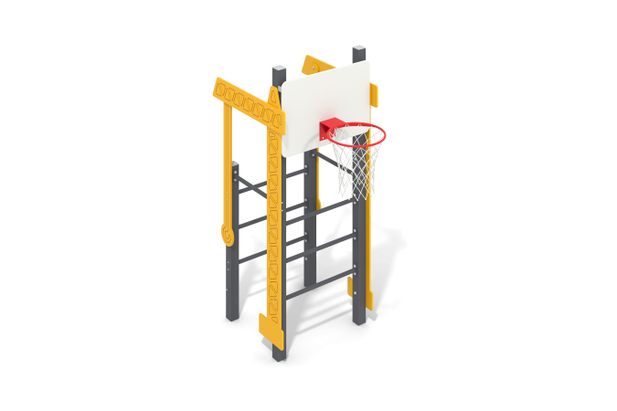

Size, mm: | 960x1666x2305 | Weight, kg: | 136.619
Material characteristics
Materials: moisture-resistant birch plywood, metal, acrylic paint, powder paint.
The complex is installed on 4 support pillars made of 80 mm square metal pipe and 3 mm wall thickness. The frame is made of metal pipes with a diameter of 26 mm with a wall thickness of 2.8 mm and metal profile pipes 40x20 mm with a wall thickness of 2 mm. The connection of metal structural elements is carried out using bolted connections.
Decorative elements “Crane” and basketball backboard are made of high-strength, moisture-resistant birch plywood 15 mm thick. The plywood is attached to the metal frame using fasteners. The ends of the support pillars are closed with plastic plugs.
The basketball hoop is attached to the backboard and frame using fasteners.
The protruding parts of the threaded connections are closed with plastic plugs. All existing metal parts are painted with polyester powder paint.
Contents: Support posts – 4 pcs. Decorative elements “Faucet base” – 2 pcs. Decorative elements “Crane boom” – 2 pcs. Decorative elements “Crane suspension” – 2 pcs. Basketball backboard frame - 1 pc. Basketball backboard - 1 pc. Basketball hoop - 1 pc. Fastening kit - 1 pc.

