ML3515.2 |  | Pipe hooks
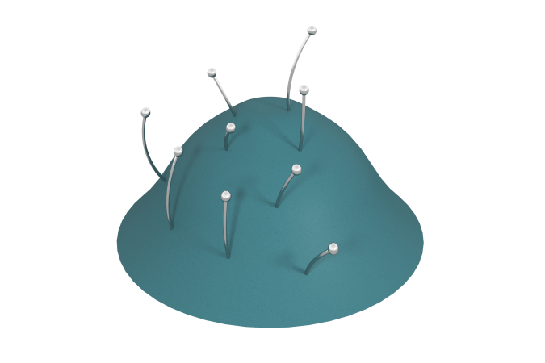

Size, mm: | 2282x2298x900 | Weight, kg: | 0
Material characteristics
Materials: stainless steel.
The hill is not included in the equipment delivery and must be manufactured and installed by the customer independently or ordered separately. The delivery includes only equipment installed on the surface of the hill.
The hooks are fixed on the surface at different distances from each other and at different angles.
Contents: hooks - 9 pcs.

