22.078 |  | Straight slide H1000
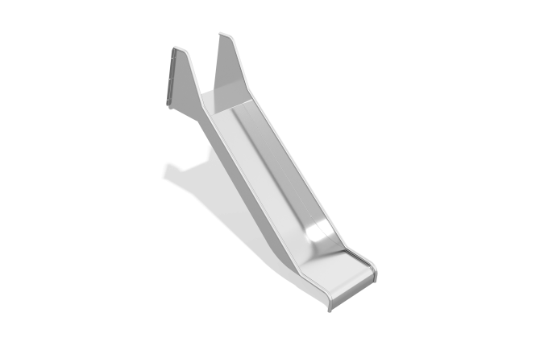

Size, mm: | 548x1789x1513 | Weight, kg: | 33.90719
Material characteristics
Main materials: stainless steel.
The slide is made of stainless steel sheet 3 mm thick. The handle tube is presented in the form of a round stainless steel tube with a diameter of 26.9 mm and a wall thickness of 2 mm.

