35.031 |  | Balancer for dogs
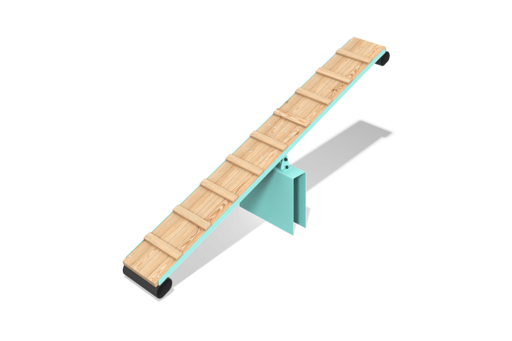

Size, mm: | 600x2800x1050 | Weight, kg: | 0
Material characteristics
Materials:
metal, planed boards (larch)
The "Balance" element is a dog equipment consisting of one section.
The design is a bridge hinged to the base.
The base is a welded structure made of a 5 mm thick sheet.
The bridge consists of 4 boards with a cross-section size of 90x35 mm, fixed to a metal frame, as well as 20 mm thick beams.
The bridge frame consists of two 40x40x4 mm profile corners and 4 mm thick sheet crossbars.
The movable part of the support block rotates in two radial bearings mounted in a sleeve.
To prevent sudden impacts, dampers are installed at the ends of the bridge.
The metal parts are painted with polymer paint, and the boards are coated with varnish.
Accessories:
base - 1 piece, balance bridge - 1 piece, balance unit - 2 pieces, fastening kit.

