23.015 |  | Double Play Panel Cat and Dog
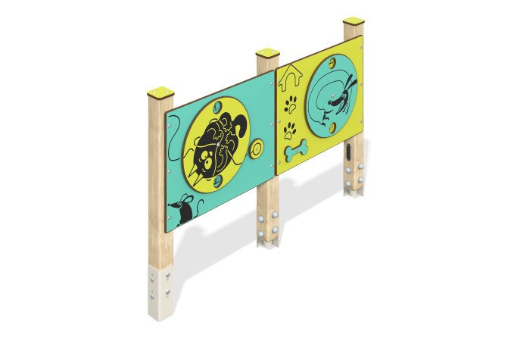

Size, mm: | 108x1360x1167 | Weight, kg: | 27.468
Material characteristics
Main materials: softwood timber, HPL plastic, metal, stainless steel fasteners.
Contents: embedded parts - 1 set, support stands - 3 pcs., "Cat" game panel - 1 pc., "Dog" game panel - 1 pc., fastening kit - 1 pc.
Design and color palette of equipment according to the sketch.
The educational element consists of three supports made of laminated veneer lumber, on which two game panels are fixed: “Cat with a ball” with rotating disks depicting a cat and a ball, and “Dachshund” with a rotating disk depicting a dachshund. Also on the panels in a circle are thematic drawings that can be viewed by rotating the “cat” and “dachshund” disks through the round slots.
The support posts are made of laminated coniferous timber with a cross-section of 80x80 mm. The profile is square, the corner radius is R10. The game elements are made of double-sided HPL plastic with UV protection, 10 mm thick. Drawings are applied to the panels using engraving and UV printing. Caps made of HPL plastic with UV protection 10 mm thick are installed on the upper part of the support posts.
The complex uses stainless steel fasteners.
Element coverage:
- metal - powder zinc primer, powder paint;
- timber - glazing primer, water-dispersion varnish.

