25.014 |  | Trampoline 3-squared
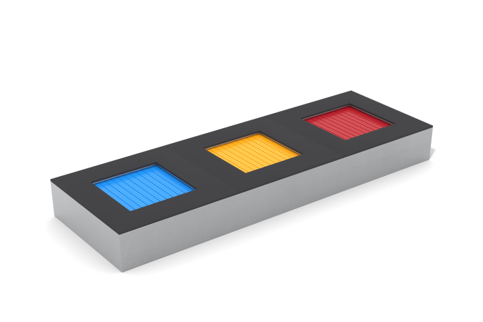

Size, mm: | 1350x4050x420 | Weight, kg: | 519
Material characteristics
Materials: frame – galvanized steel 3 mm thick; jumping surface - elements made of TPR, steel rope 4 mm thick; sides - EPDM chips.
The complex consists of 3 square trampolines with dimensions 1350mm x 1350mm. The size of the jumping surface of each trampoline is 750mm x 750mm. The frames of the trampolines are made of galvanized steel sheets 3 mm thick and have additional stiffening ribs inside. Handles are installed on the metal frame on the outside to ensure the transfer and installation of the trampoline.
The jumping surface is assembled from assembled elements made of compacted technical thermoplastic elastomer with high resistance to abrasion and weathering. The elements of the canvas are connected to each other by steel ropes (cables) 4 mm thick and form a continuous jumping surface without gaps between the individual elements.
The ends of the cables are connected through thimbles to the body using cone-shaped springs hidden under the frame of the trampoline. The springs have a galvanic coating and an elongated ear shape for easy access when servicing the trampoline.
To ensure safety, the edges of the trampoline are covered along the perimeter with rubber plates 300 mm wide and 20 mm thick, made of EPDM chips.

