19.067 |  | Sandpit Gravity
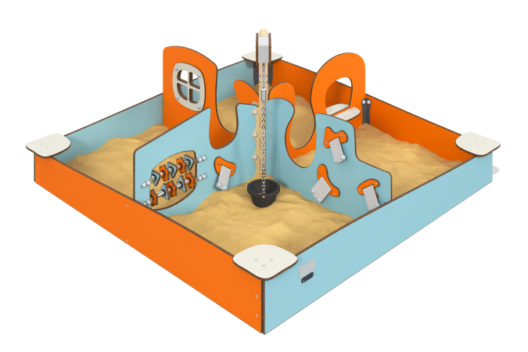

Size, mm: | 2125x2125x1018 | Weight, kg: | 116.03
Material characteristics
General description of the design
A square sandy courtyard divided into four areas by interactive partitions. The interactivity of the partitions allows for communication between areas: by rotating the central “tap”, you can move a bucket between areas, filling it with sand and emptying it.
Materials and components
Powder-painted steel with a layer of zinc-containing primer, HPL plastic, stainless steel fasteners, galvanized or stainless steel chain.
Metal parts are coated in two layers: as the first layer, a powder zinc-containing primer is applied, which is a powder mixture based on epoxy resin, zinc and targeted additives, and polymerized in a high-temperature chamber. As a finishing layer, polyester powder paint is applied, which is a homogenized powder mixture of polyester resin, hardeners, pigments, fillers and modifiers selected to ensure weather resistance and light resistance. The finishing layer is polymerized in a high-temperature chamber.
Frame
It is a system of four mutually perpendicular panels made of HPL plastic 10 mm thick, forming the external contour of the sandbox. The frame elements also include a vertical round pipe to which dividing panels and a rotating console with a bucket on a metal chain are attached.
Infills and fencing
Decorative, structural and gaming panels are made of durable, moisture-resistant and UV-resistant HPL plastic 10 mm thick.
The abacus base is made of UV-resistant polypropylene six-strand reinforced rope with a diameter of 16 mm. Rope connections are made of durable plastic and (or) specialized stainless or aluminum fasteners.
All edges of HPL parts are processed and smoothed using special edge knives or milling.
Interactive elements
The complex includes special developments - interactive elements, exhibits, educational stands and modules for games.
Movable woven patches
It is located on one of the vertical dividing panels and does not have a rigid fixation in its grooves, excluding plastic stops at the ends of the patches. Interaction is the simplest movement of a patch perpendicular to the plane of the panel through a groove.
Abacus
A standard unit consisting of plastic rotation forms attached to a metal round pipe that can move along the pipe. Is a street adaptation of the abacus.
Window
It is a decorative overlay with four holes placed on a dividing panel.
Shop
An element functionally similar to a window, however, it differs in that there is a window sill on either side of the opening dividing panel, offering a store-style interaction.
Movable bucket on chain
All four dividing panels have a cutout in the upper part, and the height of the expansion of this cutout relative to the bottom point of the product is different for all panels. A bucket on a chain, cantilevered onto a rotating mechanism, expands the possibilities of interaction between areas of the product, adding an element of exchange of sand and/or objects.

