MG4051 |  | Play System
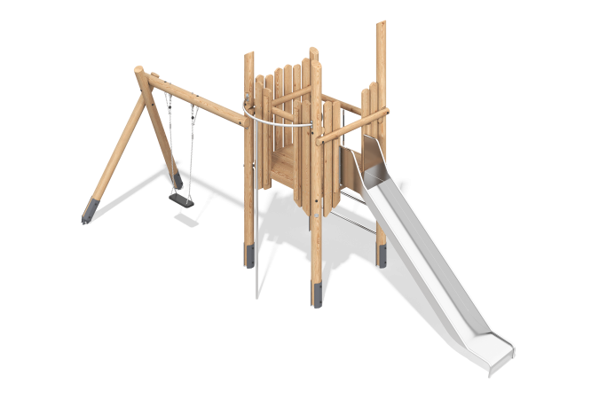

Size, mm: | 2530x6500x3470 | Weight, kg: | 0
Material characteristics
Materials: softwood (larch, larch boards, pine); metal, stainless steel, six-strand reinforced polypropylene rope, rubber.
Package includes: 1 stainless steel slide, 1 set of decorative elements, 6 support posts, 1 ladder, 1 set of flooring, 1 vertical pole, 1 swing with suspension, 1 set of fasteners.
The play complex consists of a single platform and a swing with a rubber suspension. The support posts are made of rounded larch timber with a diameter of 140 mm. The frame of the playhouse, play elements, and decorative elements are made of planed grade A pine boards measuring 190 mm x 35 mm and 90 mm x 35 mm. The playhouse floors are made of larch boards measuring 25mm x 140mm x 4000mm and 25mm x 190mm x 6000mm, and the floor frame is made of 100x100mm larch timber.
The rungs are made of rounded larch timber with a diameter of 90mm.
The playhouse includes:
- a sliding pole made of stainless steel pipe with a diameter of 33.7mm and a wall thickness of 2mm.
- the steps on the ladders are made of stainless steel pipe with a diameter of 33.7mm and a wall thickness of 2mm.
- a climbing rope made of six-strand reinforced polypropylene rope with a diameter of 16mm.
- a swing with a rubber suspension, including a stainless steel chain and a suspension bracket.
The playhouse includes one straight slide. The 1.5 m straight slide consists of a ramp and sides. The ramp is made of 2 mm thick stainless steel sheet, and the sides are made of 26.9 mm diameter round stainless steel pipe with a 2 mm wall thickness. The starting platform of the straight slide is equipped with a crossbar made of 90 mm diameter round larch timber.
The complex uses stainless steel fasteners. Protruding threaded connections and exposed pipe sections are covered with plastic plugs.
Finishing of the elements:
- Metal: zinc powder primer, powder paint;
- Timber: translucent primer, water-based varnish.

