40.077 |  | Fencing Section
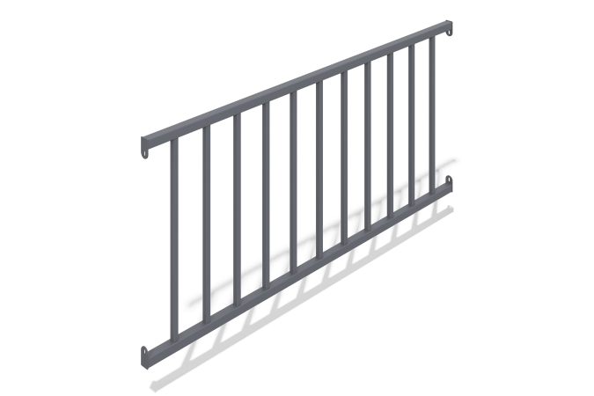

Size, mm: | 50x2000x900 | Weight, kg: | 0
Material characteristics
Materials: metal.
The fence is made of a 40x40x2 square tube, a 20x20x1.5 square tube and a 4 mm metal sheet.
Coating of the elements:
- metal - powder zinc grunt, powder paint;

