28.041 |  | Sports and Play System Chess climb
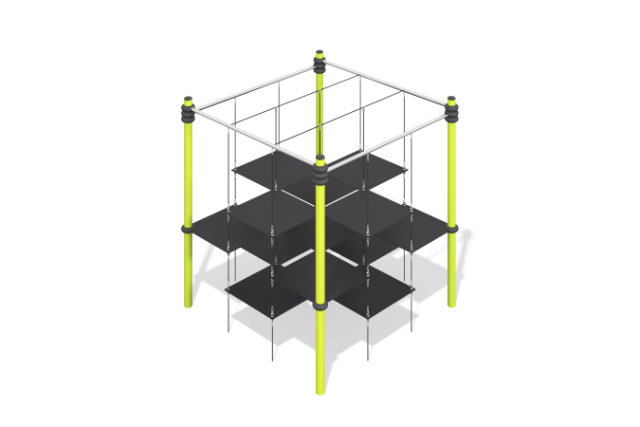

Size, mm: | 3230x3230x3300 | Weight, kg: | 675
Material characteristics
Materials: metal.
Package: support posts - 4 pcs., fastener kit - 1 pc.
The support posts of the frame are made of 133x6 powder-coated pipes. The horizontal crossbars of the frame are made of stainless steel polished pipes with a diameter of 60x3 mm, steel grade AISI 304. The frame of the complex is assembled into a single structure using prefabricated aluminum clamps with an internal diameter of 133 mm with a powder coating.
Protruding parts of threaded connections and open parts of pipes are covered with plastic plugs
Coating of elements: metal - powder zinc primer, powder paint.

