17.049 |  | Swing Frame Towers
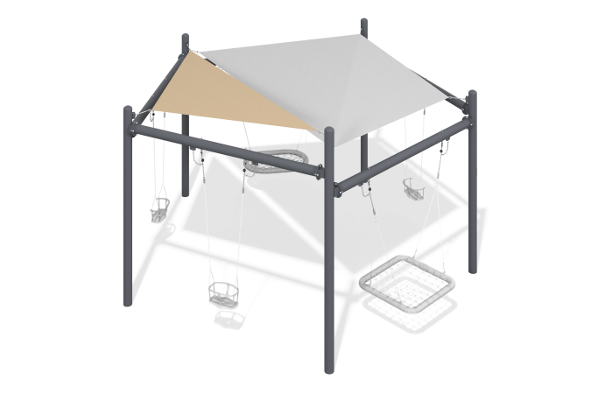

Size, mm: | 5198x5458x3160 | Weight, kg: | 507.603
Material characteristics
General description of the design
The product is a set of a pentagonal frame with an awning canopy for a swing, two suspensions with rope weaving and three suspensions on chains.
Materials and components
Powder-painted steel with a layer of zinc-containing primer, plastic, stainless steel fasteners. The swing includes three suspensions on chains and two “nest” suspensions with a weighted rim and two plastic suspensions. The weaving inside the ring is made of four-strand reinforced rope with a diameter of 16 mm. The swing is equipped with suspensions made of four-strand reinforced rope. The length of the hangers is 1340 mm. The swing is designed for intensive use, can withstand a load of up to 250 kg - suitable for playgrounds in public places (parks, squares, local areas).
Metal parts are coated in two layers: as the first layer, a powder zinc-containing primer is applied, which is a powder mixture based on epoxy resin, zinc and targeted additives, and polymerized in a high-temperature chamber. As a finishing layer, polyester powder paint is applied, which is a homogenized powder mixture of polyester resin, hardeners, pigments, fillers and modifiers selected to ensure weather resistance and light resistance. The finishing layer is polymerized in a high-temperature chamber.
Frame
It consists of metal profile pipes with a diameter of 133 mm with a wall thickness of 4.5 mm as pillars, connected at the top by crossbars, to which the awning canopy and swing suspensions are attached.

