23.022 |  | Educational Module Glucophone
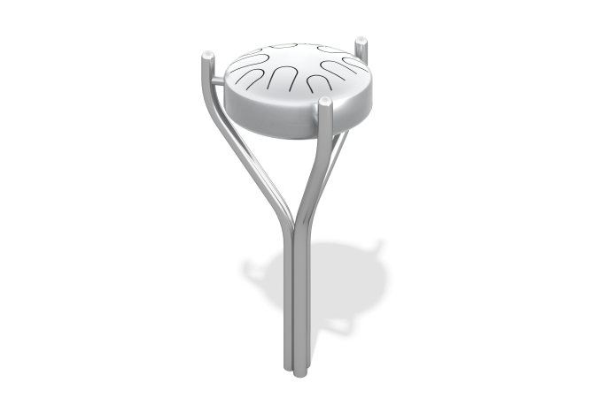

Size, mm: | 380x380x670 | Weight, kg: | 7
Material characteristics
Materials: stainless steel, pressed rubber.
The game element is made in the form of a musical instrument “Glucophone”. A glucophone is a percussion instrument that consists of two metal hemispheres made of stainless steel with a wall thickness of 2 mm. In the lower hemisphere there is a resonator hole, and on the upper hemisphere petals of different sizes are cut out in a circle, when struck they produce sounds of different tones. The support posts are made of stainless steel pipe with a diameter of 42 mm.
The percussion part of the metal sticks is made of rubber. The metal sticks are attached to the body of the glucophone using steel cables.
Contents: glucophone with sticks assembled – 1 pc.

