24.012 |  | Sports equipment Balancing posts
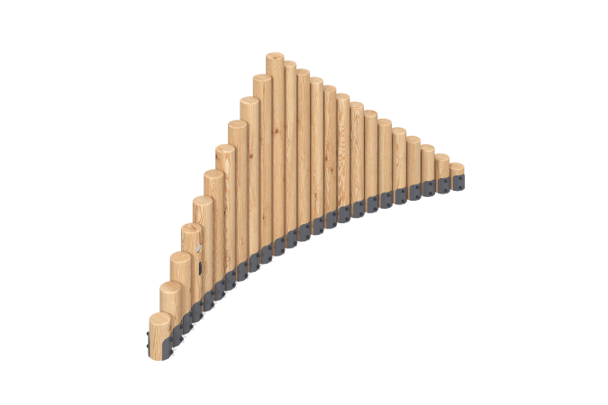

Size, mm: | 635x3272x1500 | Weight, kg: | 266.1031
Material characteristics
Materials: coniferous wood - pine, steel, stainless fasteners.
Package contents: columns - 24 pcs., a set of mortgages - 1 pc., a set of fasteners - 1 pc.
The sports element consists of 24 columns of different heights. The support posts are made of glued rounded pine timber.
Coating of the elements:
- metal - powder zinc grunt, powder paint;
- timber - lessening primer, water-dispersion varnish.

