19.089 |  | Sandpit Circle
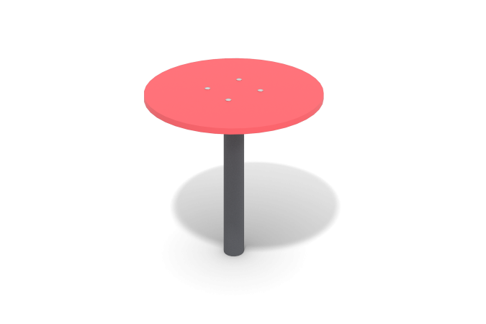

Size, mm: | 500x500x546 | Weight, kg: | 34.996
Material characteristics
Materials:
- Plywood 15 mm thick;
- Round steel pipe;
- Steel sheet;
- Powder paint;
- Water-based paint;
- Stainless steel fasteners.
The product is a table consisting of a stand and a tabletop.
The stand is made of a 57 mm round pipe with a wall thickness of 3 mm, the table top is made of plywood with a thickness of 15 mm. The tabletop is connected to the stand using stainless steel fasteners.
Equipment:
- Stand 1 piece;
- Table top 1 piece;
- Set of fasteners and plugs 1 pc.

