37.011 |  | Stylophone
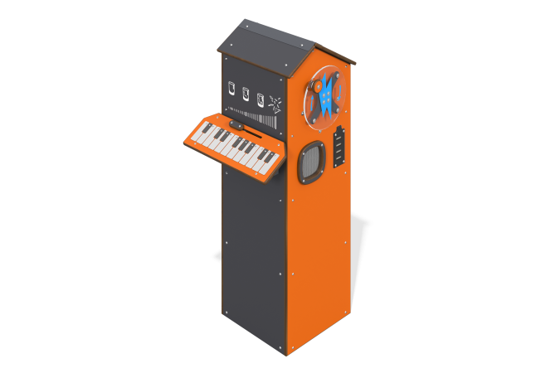

Size, mm: | 517x617x1238 | Weight, kg: | 69.363
Material characteristics
Educational game module
The module is a generator set located inside a housing made of HPL plastic. On one of the sides of the case there is a “stylophone” gaming element. The concept of the module is based on the idea of ​​creating a melody. When the user presses one of the metal keys on the keyboard, it completes a circuit and the corresponding note is played. The slider on the stylophone panel allows you to change the sound strength.
Also installed on the case are a speaker, a charge indicator in the form of a battery, and a rotating panel made of monolithic polycarbonate with a handle, the rotation of which charges the generator.
Materials: HPL plastic, metal, stainless steel.

