34.132 |  | Concrete park bench Cylinder
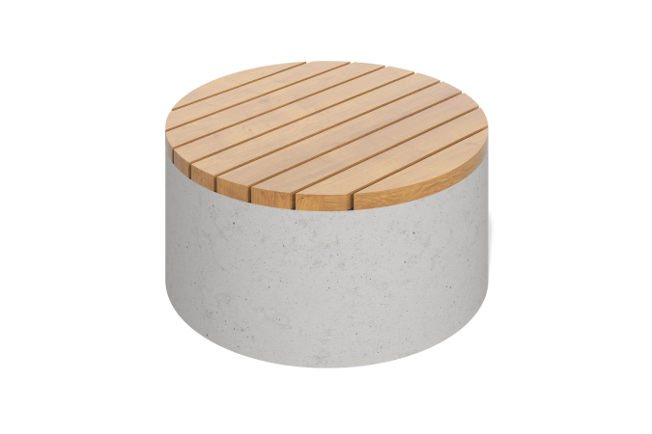

Size, mm: | 700x700x450 | Weight, kg: | 670
Material characteristics
Materials: concrete, softwood (pine)
Package includes: bench - 1 pc. Concrete with M-500 grey Portland cement as a binder. Concrete compressive strength class: B25. Frost resistance grade: F 150. Composition: natural stone of 5-10 mm fraction as a filler. Front surface: polished
The seat pads are presented in the form of pine boards treated with a special impregnation that reduces water absorption and provides protective functions - 2 layers of yacht varnish with intermediate sanding.

