34.152 |  | Topiary Hermelin
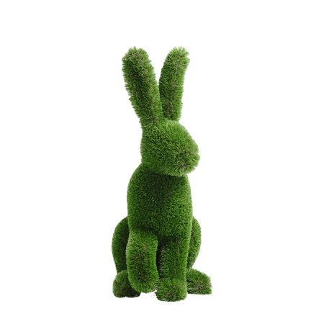

Size, mm: | 450x1100x700 | Weight, kg: | 0
Material characteristics
Material: fiberglass,
artificial turf.
Included: topiary - 1 pc.

