34.153 |  | Topiary Bear
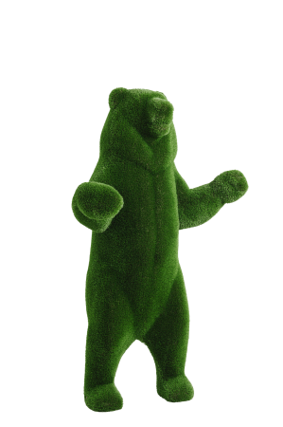

Size, mm: | 970x1520x2640 | Weight, kg: | 0
Material characteristics
Material: fiberglass,
artificial turf.
Included: topiary - 1 pc.

