34.154 |  | Topiary Bull
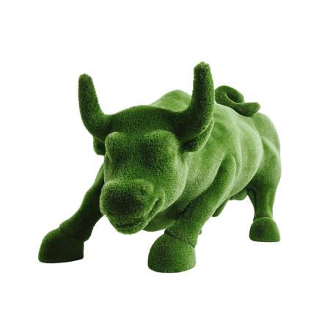

Size, mm: | 2450x4000x2700 | Weight, kg: | 0
Material characteristics
Material: fiberglass,
artificial turf.
Included: topiary - 1 pc.

