39.117 |  | Urn
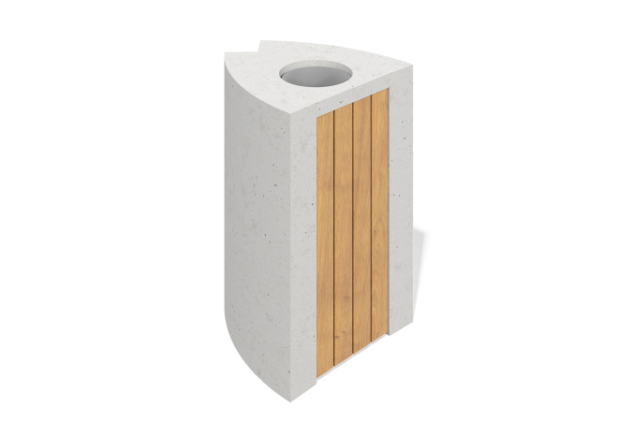

Size, mm: | 400x500x700 | Weight, kg: | 150
Material characteristics
Material: architectural concrete.
Concrete compressive strength class: B25
Frost resistance grade: F 150
Water resistance grade: W 6
Composition: White Portland cement M-500
Filler: marble chips of fraction 5-10 mm.
Front surface: smooth, polished, with
the structure of natural stone.
Type: monolithic structure.

