MG4535 |  | Sports equipment for workout
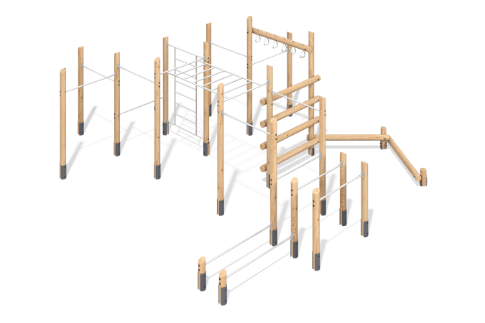

Size, mm: | 7054x7983x2924 | Weight, kg: | 863.8
Material characteristics
Materials: softwood lumber (larch), metal, stainless steel, stainless steel fasteners.
Package includes: 1 set of embedded parts, 22 support posts, 2 sets of monkey bars, 1 set of wall bars, 12 rungs, 1 ladder, 1 set of fasteners.
The support posts are made of rounded larch lumber with a diameter of 140 mm.
The rungs, wall bars, and monkey bars are made of round stainless steel pipe with a diameter of 33.7 mm and a wall thickness of 3 mm. The ladder is made of rounded larch lumber with a diameter of 90 mm.
The set uses stainless steel fasteners. Protruding threaded connections and exposed pipe sections are covered with plastic plugs.
Finish:
- Metal - zinc powder primer, powder paint;
- timber - glazing primer, water-dispersion varnish.

