MG4531 |  | Sports equipment for workout
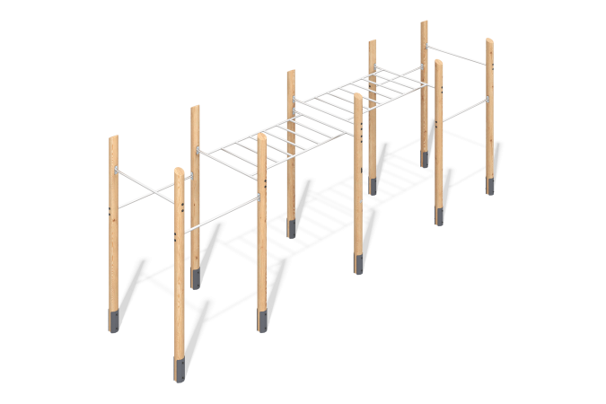

Size, mm: | 1720x7450x2800 | Weight, kg: | 434.7
Material characteristics
Main materials: softwood lumber, metal, stainless steel, stainless steel fasteners.
Package includes: 10 embedded parts; 10 support posts; 2 monkey bars; 6 crossbars; 1 set of fasteners.
The support posts are made of insulated, 140 mm diameter larch lumber. The profile is round, with a corner radius of R10.
The monkey bars and crossbars between the posts are made of stainless steel pipe with a diameter of 33.7 mm and a wall thickness of 2 mm.
The set uses stainless steel fasteners. Protruding threaded connections and mounting holes are covered with plastic plugs.
Finish:
- Metal: zinc powder primer, powder paint;
- Lumber: translucent primer, water-based varnish.

