MG4526 |  | Sports equipment for workout
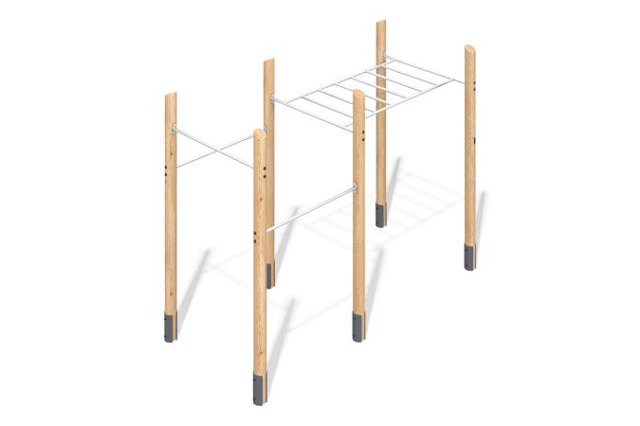

Size, mm: | 1680x3825x2800 | Weight, kg: | 247.9
Material characteristics
Materials: softwood timber - larch, metal, stainless steel, stainless steel fasteners.
Complete set: embedded parts - 1 set, support posts - 6 pcs, monkey bars - 1 set, crossbars - 3 pcs, fastener set - 1 set.
The support posts are made of rounded larch timber with a diameter of 140 mm.
The crossbars and monkey bars are made of a round stainless steel pipe with a diameter of 33.7 mm and a wall thickness of 3 mm.
The set uses stainless steel fasteners. Protruding parts of threaded connections and open parts of pipes are covered with plastic plugs.
Coating of elements:
- metal - zinc powder primer, powder paint;
- timber - glazing primer, water-dispersion varnish.

