MG3516 |  | Sports equipment Crossing
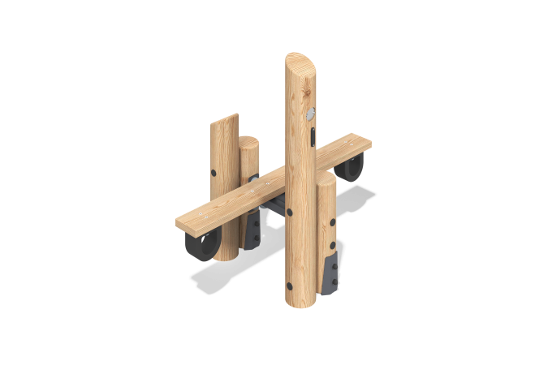

Size, mm: | 660x1200x1133 | Weight, kg: | 405.6677
Material characteristics
Materials: softwood (larch), metal, stainless steel, rubberized fabric conveyor belt.
Package includes: 4 support posts, 1 walkway board, 1 crossbar, 1 fastener kit.
The support posts are made of rounded larch timber with a diameter of 140 mm.
The walkway board is made of larch timber measuring 140 x 35 mm. To prevent impacts, the board is equipped with bumpers made of rubberized fabric conveyor belt.
The kit uses stainless steel fasteners. Protruding threaded connections and exposed pipe sections are covered with plastic plugs.
Finishing:
- Metal: zinc powder primer, powder paint;
- Timber: translucent primer, water-based varnish.

